Machine learning



**Group 40**

Name: Stefan Winter

Student number: 2067606

Name: Joost Oudesluijs

Student number: 2056392

Name: Joost Schutte

Student number: 2069625

[880083-M-6](https://tilburguniversity.instructure.com/courses/5509)

Dr. Güven Ç and Dr. Önal, I.

Department of Cognitive science and Artificial intelligence

School of Humanities and Digital sciences

Tilburg University

June 2021

|  |
| --- |
|  |

# Task 1

**Model 1**

**Support vector machine**

The Support Vector Machine (SVM) is an algorithm that fits a hyperplane to classify all datapoints to categories in an N-dimensional space (Ghandi, 2018). This hyperplane (the black line in the image below) maximizes the distance or margin (light blue area) between the different classes. The Support Vectors are the closest points to the classifier and determine the position of the hyperplane.

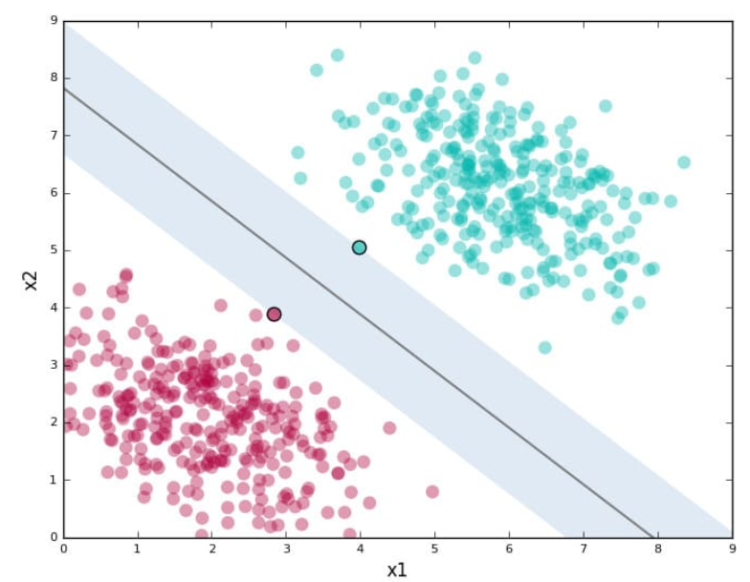

Figure : Support Vector Machine visualized

To correctly classify the datapoints, a kernel function projects low-dimensional data into a higher-dimensional space. Enhancing the dimensions makes it possible to appropriately divide the observations into different classes. Therefore, Support Vector Machines work more effectively in higher dimensional spaces, or in datasets with a high number of input features (Ghandi, 2018). Since SVM can handle multiclass classification problems and works well with a high number of input features, this model is applied for task 1.

**Input to classifier**

To represent the image data from “train_data_label.npz” and “test_data_label.npz”, the vectors are standardized with the StandardScaler function from scikit-learn. What this function does is subtract the mean from every observation and divide that by its standard deviation. Particularly for SVM, the algorithm assumes that all features are centered around zero and have variance in the same order (scikit-learn, 2021). The data does not to be split into a training and a validation set because using cross-validation and grid search for parameter tuning handles this automatically.

**Hyperparameter tuning**

To optimize this model, a pipeline is created in which multiple hyperparameter settings are evaluated. This is done using the GridSearchCV function from scikit-learn, where five-fold cross-validation is applied. This means that every part of the training data is used four times for training and one time for validation purposes (Souza, Matwin, Japkowicz, 2002). In the first part of the pipeline, Principal Component Analysis (PCA) is applied to reduce the dimensionality and the noise of the data (Husson et al., 2010). During the grid search, the n_components parameter for PCA ranged from 75 to 100 percent with increments of 1 percent. The result of this is that 90 percent of all variance can be explained using only 58 features, which is a reduction of 726 dimensions. The cost parameter (C) is the second parameter that was tuned to find a good number of samples that is allowed in the margin, to find the lowest overall error (scikit-learn, 2021). Values between 1 and 6 are used, with increments of 1. To transform low dimensional input to a higher dimensional space, multiple kernels can be applied; a polynomial function, the Radial Basis Function (RBF) and a sigmoid function.

**Model training**

The obtained training score after hyperparameter tuning is around 0.99. The best settings for PCA turned out to be a dimensionality of 91 percent variance explained. This reduces the 784 features to only 65 features. The best value for parameter C is 5. Lastly, the best SVM kernel is RBF. This makes sense since the RBF kernel and the StandardScaler both squeeze their observations to a (near) Gaussian distribution. Therefore, the RBF kernel should be the best fit (scikit-learn, 2021).

**Results**

The hyperplane that resulted from training the model, with the appropriate hyperparameter settings, gives an accuracy of 0.88 on the test set. This means that almost 90 percent of all test images are classified correctly (see Appendix 2 for the classification report). The most difficult label to classify is the letter R. The letters V, Y, K, U and W were most often incorrectly classified as an R with 38, 35, 29, 27 and 21 times respectively. R itself was classified incorrectly as U and V most often; 35 and 21 times respectively. Thus, the main problem with R seems to be with false positives, which is a precision problem.

**Model 2**

**Random forest**

Random Forest (RF) is based on decision trees. Decision trees are a supervised learning model and are often used for classification tasks (James et al., 2013). The architecture of the decision tree is comparable to a regular tree; it has roots, nodes, branches, and leaves. The root node is the starting point of the tree and splits every node with recursive partitioning based on the largest information gain (Sato & Tsukimoto, 2001). At each coming leaf node, the data is split into partitions based on the feature with the second largest information gain. This process is repeated until a base case is reached or when the label is small enough.

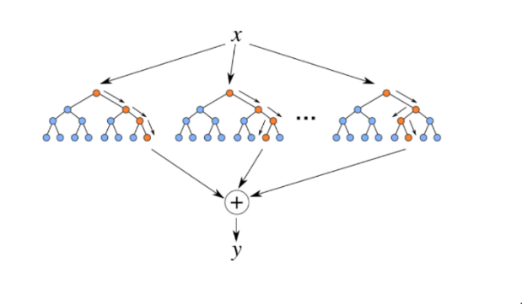Although decision trees are transparent and easily interpretable, this model is quite prone to overfitting. To overcome this problem, Random Forests are introduced. RFs are different from decision trees in the sense that they generate multiple trees. The process of generating multiple trees is done by randomly sampling the training data and random subsets of features when splitting nodes (Koehrsen, 2018). The random selection of features in each node allows the features that would otherwise be overlooked, to be used in the model (Strobl et al., 2008). The model is then trained with these random samples and subsets to decrease the total variance. However, different combinations of features could generate different predictions, which means that the final prediction is based on a majority vote.

Figure 2: Random Forest Classifier visualized

**Hyperparameter tuning**

The input to the classifier is the same as for the SVM model, so it will not be discussed here again. To increase performance of the RF, hyperparameters can be tuned in multiple ways. To find the optimal number of decision trees that comprise the random forest, the n_estimator parameter is included in the grid search. To prevent a situation in which every leave is pure and to prevent potential overfitting, the max_depth parameter is tuned. To consider different splits in features, the max_features parameter is also tuned. To set a penalty at the minimum number of samples used per leaf node, the min_samples_leaf parameter is included. The parameter min_samples_split is also included to set a baseline for the minimum number of samples required to split an internal node. The grid search to find the optimal hyperparameters is added to a pipeline. GridSearchCV is again used, with a range from 1 to 20 with increments of 1, and a cross-validation of 5. The n_components parameter for PCA is also included in the grid search, with a range from 80 to 100 percent explained variance with increment of 1. Lastly, an untuned model without PCA was also executed.

**Model training**

The best settings for the RandomForestClassifier from scikit-learn was the untuned model, with a training set accuracy of approximately 100 percent. The second-best model is the tuned version, the hyperparameter settings of which can be found in Appendix 3.

**Results**

The untuned model gives an accuracy of approximately 0.81 on the test set, which is 0.11 higher than the best version of the tuned model. Again, the most difficult label to classify is the letter R. The same letters are most often incorrectly classified for R as was the case for the SVM model. However, the order in which they occur, based on frequency, differs a bit. Furthermore, the letters S and W are also difficult to classify, but still perform slightly better than R (see Appendix 4). What these three letters all have in common is that they show higher false positives rates, which leads to worse precision when compared to recall.

**Comparison between models**

The SVM model shows a better test performance than the RF model. The accuracy scores between the two models show a difference of 0.08 accuracy in total. This difference is mainly caused by the letters S and W that perform approximately 20 percent worse on the RF model. Other letters performed roughly the same; within 5 percent of each other. A remarkable finding is that both models seem to have problems to correctly classify the letter R. Furthermore, both models tend to show higher rates of false positives, and therefore have a lower precision, on the letters with low test set scores. The last comparison between the models is runtime. The time it takes to train the Random Forest model is only 15 seconds, whereas the SVM model takes four times longer. However, this is only a small absolute difference, which means that the SVM model is the overall best option.

# Task 2

Description of your experiments and results including:

* features used
* learning model and algorithm used
* parameter tuning
* description of method or system built to perform classification

discussion of experiments run and performance of your solution (this may include analysis such as confusion matrix, accuracy per class, etc.)

# Reference

Breiman, L. (2001). Random forests. Machine learning, 45, 5-32.

Gandhi, R. (2018b, July 5). Support Vector Machine — Introduction to Machine Learning Algorithms. Retrieved from https://towardsdatascience.com/support-vector-machine-introduction-to-machine-learning-algorithms-934a444fca47

Koehrsen, W. (2018, December 1). An Implementation and Explanation of the Random Forest in Python. Retrieved from <https://towardsdatascience.com/an-implementation-and-> explanation-of-the-random-forest-in-python-77bf308a9b76

Sato, M. and H. Tsukimoto. 2001. Rule extraction from neural networks via decision tree induction. In Proceedings of the International Joint Conference on Neural Networks.

Strobl, C., Boulesteix, A. L., Kneib, T., Augustin, T., & Zeileis, A. (2008). Conditional variable importance for random forests. BMC bioinformatics, 9, 307.

Scikit-learn (2021). [sklearn.preprocessing](https://scikit-learn.org/stable/modules/classes.html#module-sklearn.preprocessing).StandardScaler. Retrieved from <https://scikit-learn.org/stable/modules/preprocessing.html>

Souza, J., Matwin, S., Japkowicz, N. (2002). *Evaluating Data Mining Models: A Pattern Language* School of Information Technology and Engineering University of Ottawa.

# Appendices

## 1 Group work

### Task 1

Stefan Winter

* Explaining Sourcetree
* Generating SVM and pipeline

Joost Oudesluijs

* Generating Neural network
* Describing task 1 on paper

Joost Schutte

* Generating random forest and gridsearch

### Task 2

Stefan Winter

Joost Oudesluijs

Joost Schutte

## 2 Classification report SVM

Table 1: Visualized classification report with the best hyperparameter settings.

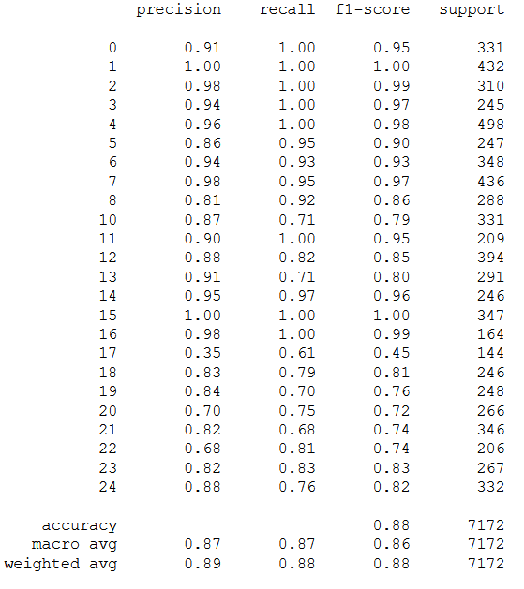

## 3 Results tuned model RF

|  |  |  |
| --- | --- | --- |
| **Parameters** | **Tuned parameter scores** | **Test set score** |
| n_components (PCA)  max_depth  max_features  min_samples_leaf  min_samples_split  n_estimators | 0.85  12  5  1  2  19 | 0.70 |

## 4 Classification report RF

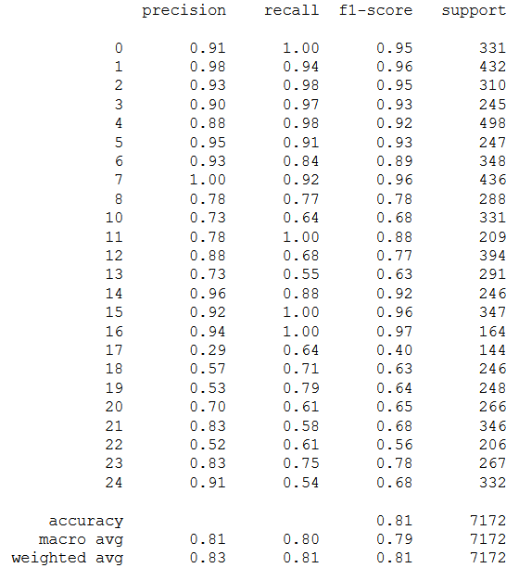

## 5 Images

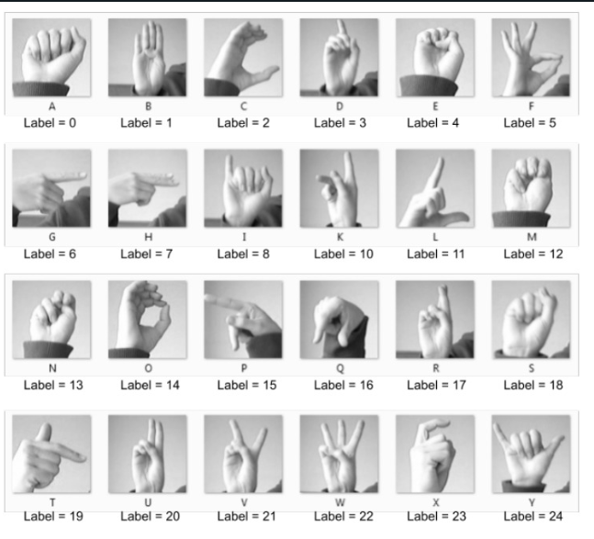

Image 1: Images of example sign language letters and their labels